Ancestor Exploration, Part I

Objective: The goal here is to draft the section of your Autogenomography* that addresses your ancestry, in particular your ancestry within the last three centuries.

Look at your 23andMe Ancestry Composition Report Summary and Scientific Details. For the Ancestry Composition Summary, you can click to expand your ancestry population breakdown. When viewing the Scientific Details of your Ancestry Composition, use the “speculative” setting.

(a) In two paragraphs, summarize what your Ancestry Composition data tells you. Use your own words to describe the numerical and graphical results you see.

(b) For the region of origin for which the Ancestry Composition analysis reveals the smallest but non-zero percentage of genetic contribution to your genome (e.g. Baltic: 1.6% or Ashkenazi: 0.2%), how many years back in your family tree would you have to go before you found one ancestor (referred to from here on as your “minor ancestor”) 100% of whose genome originated from that region? Figure 1 shows a 8 generation radial family three on which a minor ancestor has been highlighted along with his (in this example) descendents connecting him to the individual whose genome we’re exploring (in the center of the family tree.

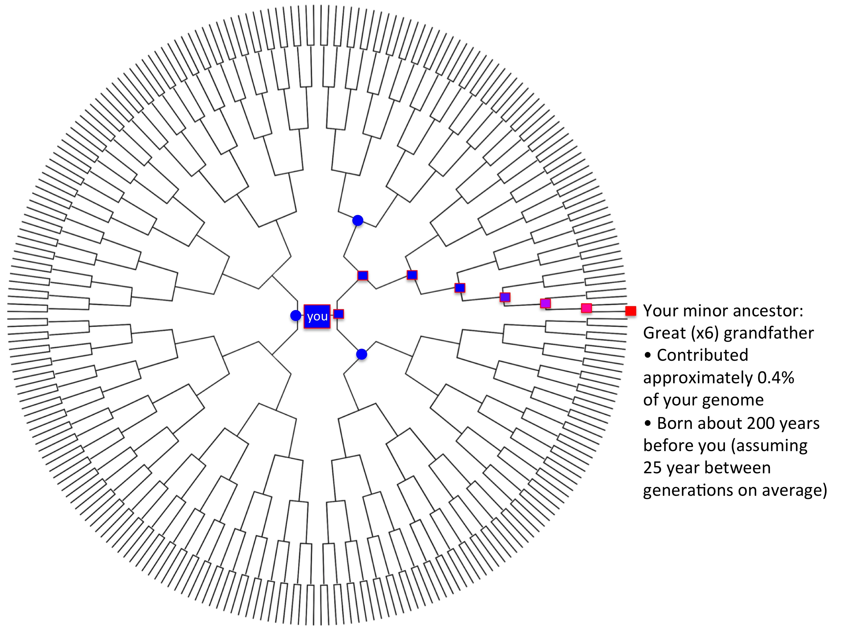

Figure 1. A minor ancestor illustrated on an 8 generation radial family tree. The mother, a grandmother and a great grandmother are shown for context, in blue to reflect the majority ancestry here. Source of tree: FamilyTreeTemplates.net

Here’s some help to get you started. Remember that the genetic contribution of a “pure” ancestor from an unusual region (e.g. not where most of your ancestors came from) to a descendent (e.g. you) will diminish 50% with every generation that passes between when they were born and when the descendent was born.

So imagine you have an ancestor who was an aboriginal Australian – and the rest of your ancestry is English. If he/she was your parent, about 50% of your genome would contain SNPs that arose in Australia, and about 50% of your genome would contain SNPs that arose in England. That ancestor (parent) would have been born approximately 25 years (an average human generation) before you.

If you had ~25% aboriginal Australian DNA in your genome, you’d have an aboriginal Australian grandparent who was born approximately 50 years before you were (two generations). And it goes on from there, with the percent of DNA from that minor ancestor reducing by 50% with every generation that has passed.
So:

DNA Relative _ Years before you that they were born
12.5% Great grandparent 75 years
6.3% Great great grandparent 100 years
3.1% Great (x3) grandparent 125 years
1.5% Great (x4) grandparent 150 years
0.7% Great (x5) grandparent 175 years
0.4% Great (x6) grandparent 200 years
0.2% Great (x7) grandparent 225 years
0.1% Great (x8) grandparent 250 years
<0.1% Great (x9) grandparent 275 years

You can see why you can't find evidence for a singular “pure” relative further back that. Their DNA has diluted to the point of non-detectability.

Assumptions
Give this “back of the envelope” calculation a little thought and you’ll see some of the many assumptions we need to make.

1) One is that you have only one of those minor ancestors. Imagine a situation where many of your distant ancestors (born more than 300 years before you) had DNA from a particular region. If the Vikings, for example, had many descendants born to people living on the coast of England, then 275 years ago, many people there would have some amount of DNA from Scandinavia, presumably received from Viking visitors from centuries earlier.

A similar argument can be made for the Neanderthal DNA in people not entirely descended from people of sub-Saharan African descent. We know that whatever his reputation in family lore, your great, great, great grandfather was not 100% Neanderthal ☺. Rather, if you have 3% Neanderthal DNA, it is likely that each of your great, great, great grandparents had pretty much that same amount.

2) Another is that our regional ancestry percentages from 23andMe are precise. Note, however, how different they are when we choose the speculative and conservative settings. See how big a difference that makes in the estimated time in history when the minor ancestor entered the family.

3) Another assumption is that the generation time is the same for each generation. Not only does it vary from century to century (generally getting longer in contemporary times), but even from generation to generation in the same century depending on the particular parents and even differing on the paternal and maternal sides (if fathers tended to be older and mothers younger).

4) Can you think of others?

If your genome typing doesn’t reveal any minor ancestors, what do you think the reasons for that might be? Do some online research of the ethnic groups that lived in the part of the world where the majority of your ancestors came from. For example, http://vietnam-culture.blogspot.com/p/54-ethnic-groups_1496.html lists 54 distinct ethnic groups in Vietnam. Similar information exists for India and other regions. What data would 23andMe need to have to be able to identify minor ancestors from a greater fraction of the globe?

(c) Make a map of the migrations of your ancestors placing the percentage value on each region 23andMe identifies [e.g. Southern Europe] and then draw arrows back along probable migration paths to where our common ancestor lived in Africa.

(d) Discuss any historical migrations that are known to have happened in the last 2000 years to or from the region(s) where your ancestors lived. You might need to investigate the history of this part of the world using Wikipedia and/or other sources.

(e) What was the way of life for most of those ancestors? Estimate the number of direct ancestors you have if you go back 2000 years. State your assumption of generation time that you feel would be appropriate for this time period.

(f) View the Scientific Details of your Ancestry Composition and look for any part(s) of your chromosome(s) that are from your minor ancestors. Identify the chromosome(s) that contain these inherited regions.

(g) Click on “Read more about how we assign your DNA to different ancestries” in the “Methodology” section of the Ancestry Composition Scientific Details. What are some things you learned?

(h) What regional populations can you identify as ones from which you have clearly not descended in the last few hundred years?

(i) What is one interesting thing you’ve learned from this exploration of your ancestors?

